Population dynamics of Rhipidomys itoan

POPULATION DYNAMICS OF THE CLIMBING MICE RHIPIDOMYS ITOAN (COSTA, 2011) IN THE BRAZILIAN ATLANTIC FOREST

SUPPLEMENTARY MATERIAL

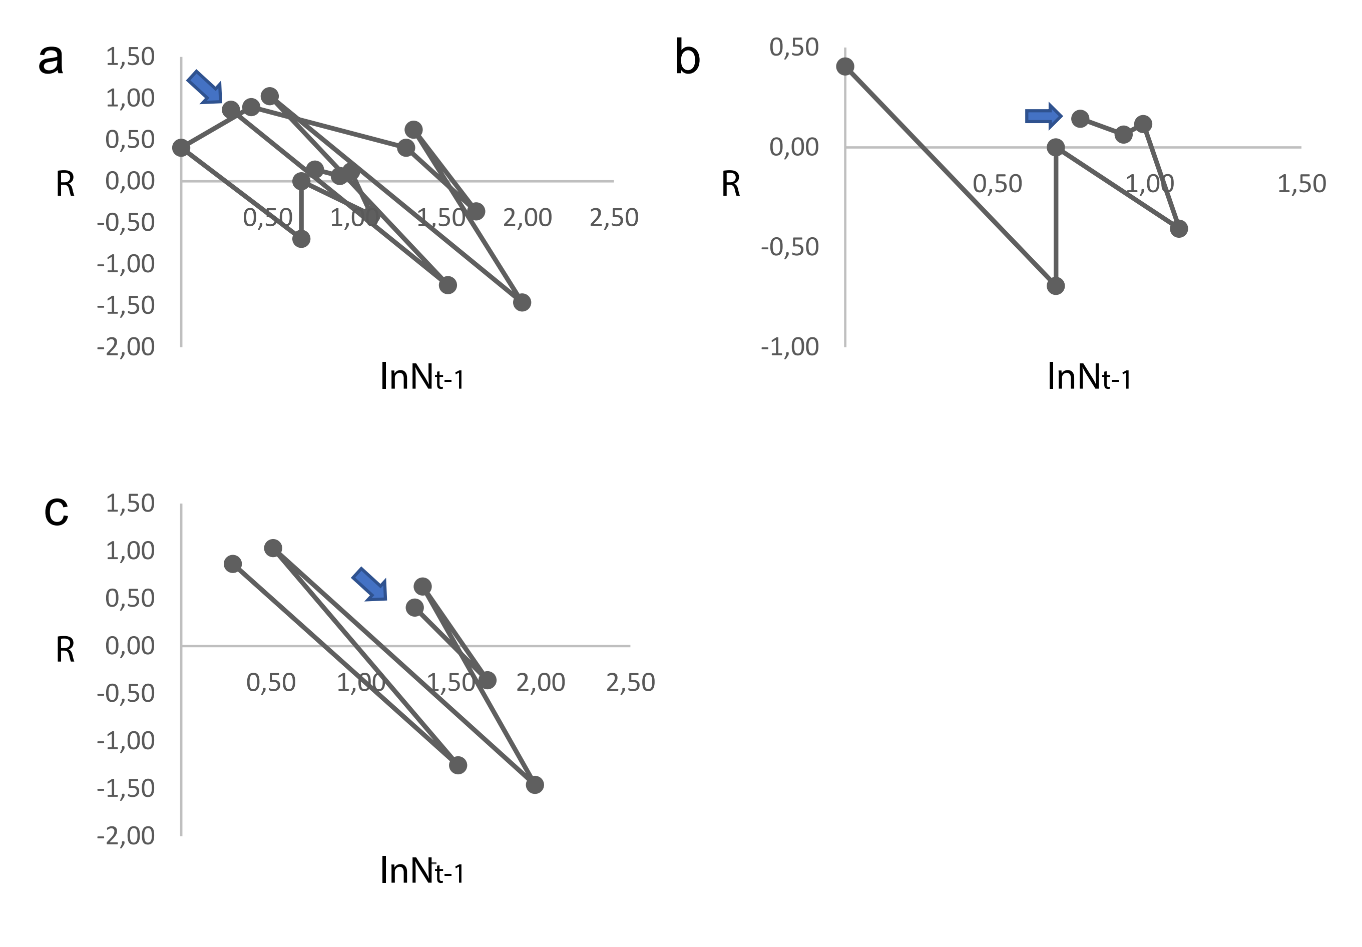
Figure S1. Phase portrait of the climbing mice Rhipidomys itoan for 16 years in an Atlantic Forest area, southeastern Brazil. a) Complete time series, b) between 2000 and 2007 (low-population sequence), and c) between 2008 and 2015 (high-population sequence). The lines connecting the points represent vectors [Nt-1, R]. (Nt-1 = population size with a lag of one year, R = per capita population growth rate). The blue arrow indicates the beginning of the time series.

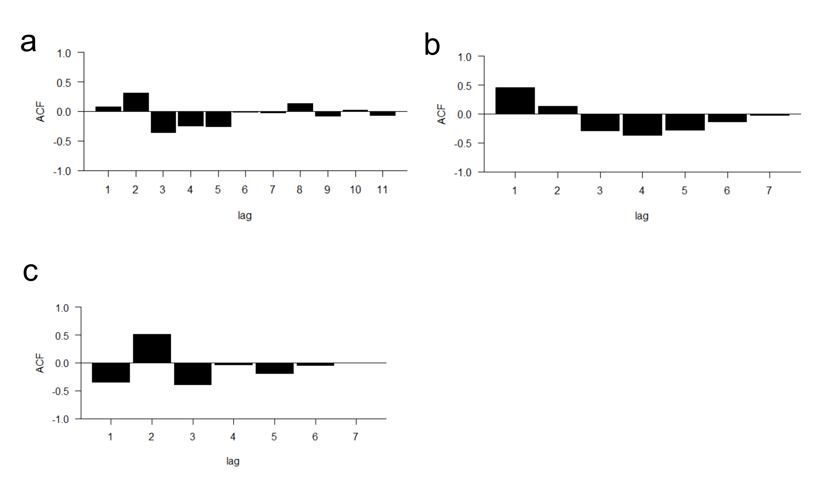

Figure S2. Autocorrelation function of the climbing mice Rhipidomys itoan for 16 years in an Atlantic Forest area, southeastern Brazil. a) ACF of the complete time series; b) ACF of the detrended time series from 2000 to 2007 (low-population sequence), and c) ACF of the detrended time series from 2008 to 2015 (high-population sequence). Lags = annual delays.

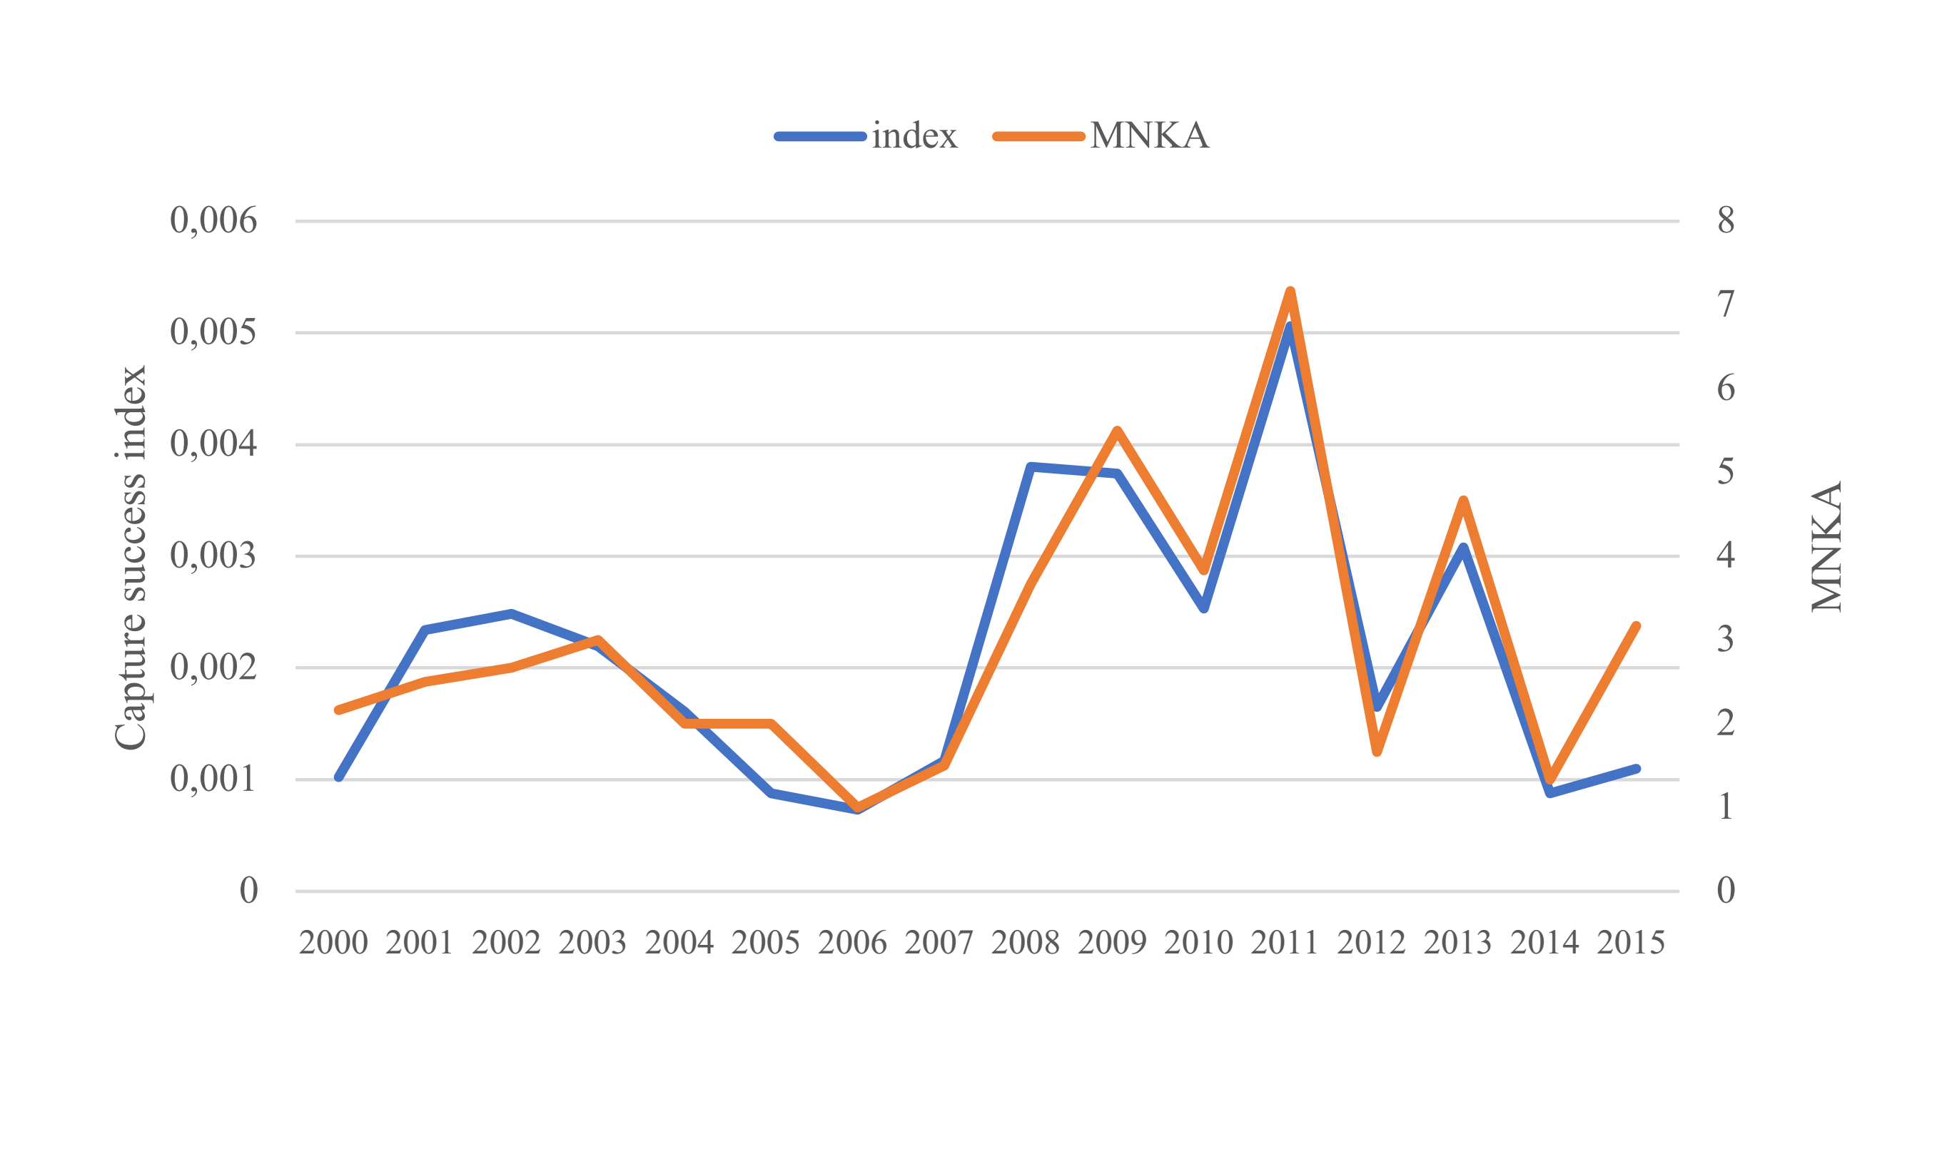
Figure S3. Comparison of population dynamics of the climbing mice Rhipidomys itoan estimated with a) the capture success index (Graipel et al. 2014) and b) the Minimum Number Known to be Alive (Krebs 1966). r = 0,90 (p < 0.001).

Table S1. Standardized parameters of the two top-ranked models predicting population size fluctuation of the climbing mice Rhipidomys itoan for 16 years in an Atlantic Forest area, southeastern Brazil. Tmax = mean maximum temperature in the current year and Tmax₋₁ = mean maximum temperature in the previous year. Significant code: * 0.05.
Variable | Estimate | Standard Deviation
First model
Intercept | 31.8285 | 12.0915 *
Tmax₋₁ | -0.9806 | 0.411 *
Second model
Intercept | 31.0536 | 12.3617 *
Tmax | -0.9554 | 0.4206 *

